Ideation Phase
Define the Problem Statements

Date | 07 March 2026
Project Name | Visualization Tool for Electric Vehicle Charge and Range Analysis
Maximum Marks | 2 Marks

Customer Problem Statement:

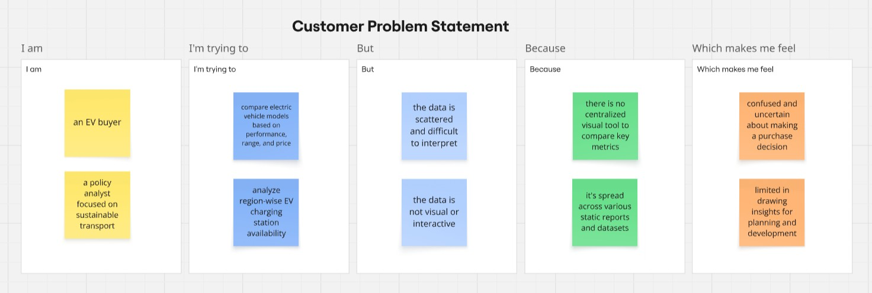

Problem  Statement (PS) | I am  (Customer) | I’m trying to | But | Because | Which makes me feel
PS-1 | an EV buyer | compare  electric  vehicle models based on performance,  range, and price | the data  is  scattered  and  difficult to interpret | there is no centralized  visual tool to compare key metrics | confused and uncertain about making a purchase decision
PS-2 | a policy analyst focused on sustainable transport | analyze region-wise EV charging station availability | the data is not visual or interactiv  e | it's spread across various static reports and datasets | limited in drawing insights for planning and development

